IAM-GUI User Guide

By Same Masaad

This guide a user manual for using the GUI software of IAM program.

Note: The iam-core.jar is not runnable. It’s just a set of methods and tools that can be used. The runnable version with GUI is iam-gui.jar.

Table of Cosntents

1 Introduction 2

1.1 Rules and information 2

2 Configuration Instructions 2

3 User Manual 2

3.1 Login Page 2

3.2 Main Menu 3

3.2.1 Add Identity 3

3.2.2 Search / Edit / Delete Identities 4

3.2.3 Edit Identity 4

3.2.4 Add User 5

3.2.5 Search / Edit / Delete Users 5

3.2.6 Edit User 6

4 The Logger 6

# Introduction

Iam-core needs a connection with a Derby Database server to function. It also uses a built-in XML file to store the same data as a backup storing medium.

## Rules and information

* An identity can have a Display Name, Email and a Unique ID.
* A user is needed to login to the program, and can have a username, password and should be associated with an identity.
* For first use, the default username and password are both “root”.
* It’s not possible to create a user that is not linked to an existing identity.
* Trying to delete an identity will automatically delete its user (if exists).
* If one storing method failed to be established, the program launches in read-only mode.
* Instead of using the built-in XML file for storing identities, a path to a custom XML file can be passed while running the JAR file. However, the built-in users’ XML will always be used.
* A configuration file must be filled with the right information and placed next to the JAR file.

# Configuration Instructions

1. To prepare the database, manual creation of a database is required. Then, the initializer SQL file provided with the JAR package (init.sql) should be ran. The queries inside this file will create the required schema and tables and will add a default identity and user called root.
2. If you are providing a custom XML, make sure it’s well formed and doesn’t have any entries different from the database’s.
3. Fill and place the configuration file next to the JAR file and name it “conf.properties”. Otherwise, you should provide the path while running the program from the command line:

java -Dconf=${pathToConfigFile} -jar ${jarName}

Please use the provided configuration file, it has comments that describe how to fill it.

# User Manual

## Login Page

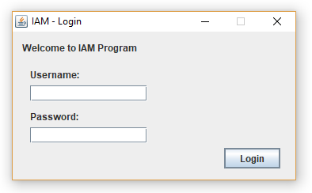

For first use: default username and password are both “root”.

## Main Menu

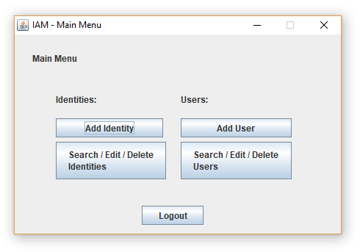

### Add Identity

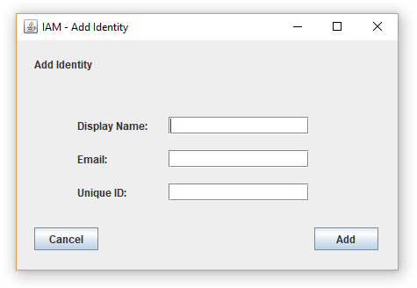

Only the Unique ID is mandatory. An identity can be created without a display name and email to reserve a unique ID for future use.

### Search / Edit / Delete Identities

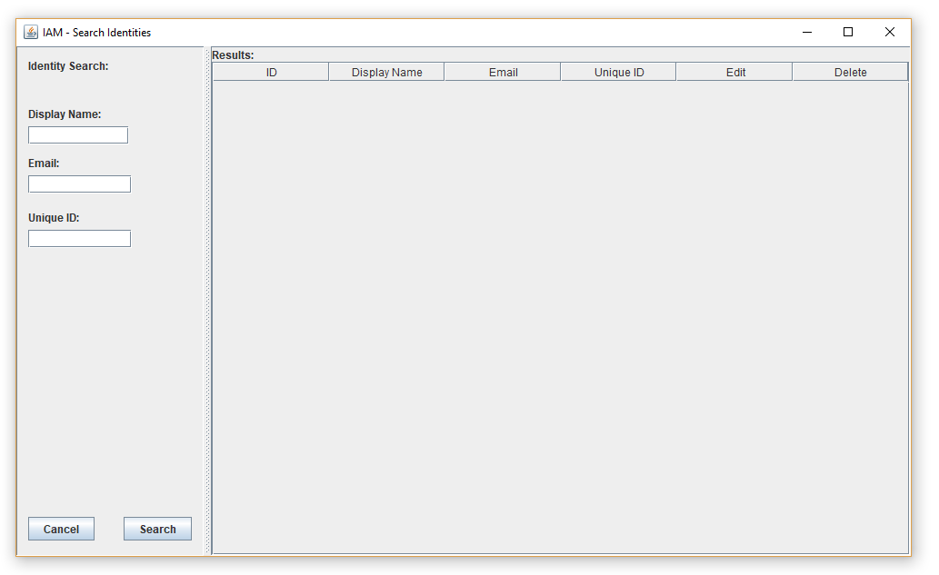

Searching without adding any criteria lists all the identities. Unique ID is case sensitive and should be exactly identical.

Example: if an identity has a Unique ID: FR201, searching for FR will list the identity whose Unique ID is exactly FR.

**Warning:** Deleting an identity will automatically delete its user (if exists)

### Edit Identity

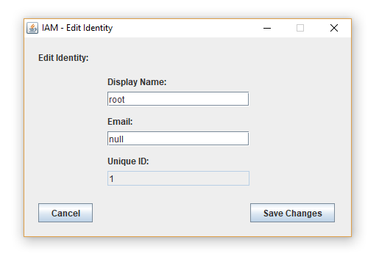

Unique ID can’t be changed after creation.

### Add User

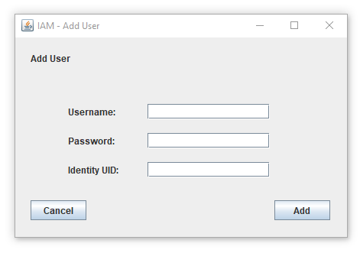

All fields are mandatory. If the identity ID was not found, a popup window pops asking to add the identity before adding the user.

### Search / Edit / Delete Users

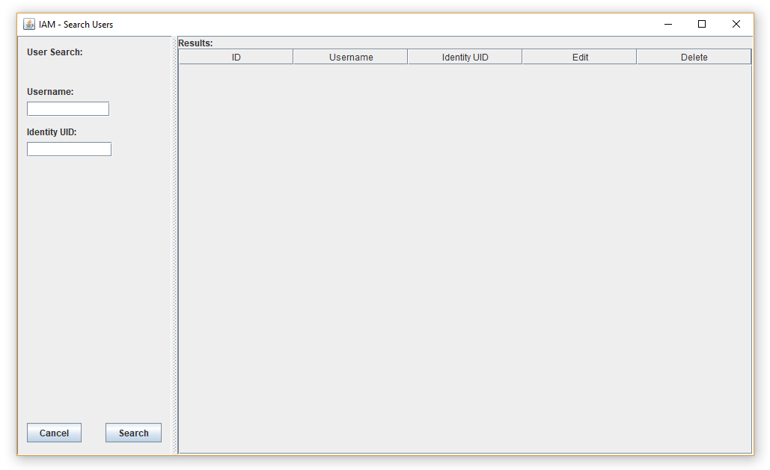

Searching without adding any criteria lists all the users. Identity UID is case sensitive and should be exactly identical.

Example: if the user’s identity has a UID: FR201, searching for FR will list the users whose identity’s UID is exactly FR.

Deleting a user will not delete the corresponding identity.

### Edit User

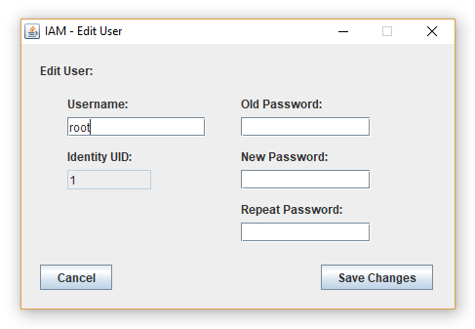

Providing the password is mandatory while changing a user’s info. And changing the identity is not possible.

# The Logger

Information, errors and warnings are logged to a file whose path is provided from the configuration file. However, if the path is not provided, the default path for the logger is the home directory of the OS user, a folder called .iam-core will be created in:

**In Windows:** %Homedrive%%Homepath%/.iam-core/application.log

**In Linux:** $HOME/.iam-core/application.log

**In macOS:** $HOME/Documents/.iam-core/application.log